## Optical Odometry Prototype Research

## Identify hardware & design parameters

By: Kenneth Laws

Date: 10/12/2017

Capture Hardware: Odometer HW

**Vehicle top speed** – typical highway, moterway, expressway speeds vary by country but most are between 90 – 130 km/hr (56 – 81 mph). As a candidate to speed, select 75 mph (121 km/hr) (33.6 m/s). Higher speeds lead to higher frame rates and greater processing requirements. Lower speeds limit operations. We might want to vary frame rate as needed but have the capability of operating at speed limit for most potential roadways. Lower top speed might be acceptable by the argument that areas with poor GPS are where greatest need for odometry solutions and these areas are usually where there are obstructions that would also limit vehicle speed. https://en.wikipedia.org/wiki/Speed_limits_by_country

A more conservative estimate of a top speed requirement could be 80 mph, which would allow speed limit operation over a larger segment of world roadways. (roughly translates to 130 km/hr)

**Frame overlap** – 50% optimizes use of available pixels for image feature matching

**Height above ground** – Ideally it would be great to put the unit under the vehicle and hence protect it from damage in collision, but practically there are problems, vehicle too low, no easy mounting solution. One mounting solution would be to use a trailer hitch receiver. These are available for most vehicles and provide a way to attach equipment to the vehicle without custom modifications to each vehicle. Typical receiver height for vehicles in our shop is about 19”. Lower vehicles, around 16” may be desirable.

**View angle of the lens** – larger view angle gives a larger image frame size and so lowers the frame rate required for a given speed. Larger view angle also leads to image distortion that will make image processing more difficult. As an initial compromise, start with a previously selected lens (3.5mm 1:1.8 ½.5”IR MP-5 lens is 60 deg by 47.5 deg full width).

**Frame size** – determined by mounting height and lens angle. For candidate parameter set, frame size is 0.234 m in the direction parallel to vehicle motion. Since vehicle change in position will generally be much larger in the direction parallel (relative to perpendicular) to instantaneous velocity, this frame size is the limiting factor.

**Pixel resolution** – determined by frame size and camera resolution. For our candidate camera, BFS-U3-13Y3C-C , 170 fps , 1280 x 1024 global shutter, we get a resolution of about 1.8 E -4 m/pix. We don’t know at this point what precision/uncertainty we will obtain from image processing, but if we assume ~5 pix, we get 0.9 mm. If we lower resolution to 640 x 480, we get about 3.7 E -4 m/pix or about 2 mm for 5 pixels. We can assume that image processing speed will be a very significant issue with this system and so for now select the lower image resolution (640 x 480) for calculations.

## Frame Rate and Image Size

**Frame rate** – Assuming 50% overlap for consecutive frames, the vehicle moves at most half the frame size in the time between images. For the above parameter set, a frame rate of 287 frames per second is required. This is higher than our candidate camera.

*Modifying parameters to achieve a 170 fps frame rate:* the above frame rate of 287 fps may present problems with component selection and processing methods and hardware requirements. The primary drivers of this frame rate are:

* Device mounting height - Increasing mounting height may be practical, but camera will also have to get further from the rear bumper to retain an unobstructed view. Further, image resolution will decrease for a given image size as the height is increased
* Lens viewing angle – wider angle lens will help but will also likely cause problems with image distortion that may affect image matching performance or require more complicated algorithms
* Overlap requirement – reducing overlap reduces the number of pixels available for image matching. There may be a limit or turning point where decreasing overlap has a dramatic effect on performance.

Of the above options, reducing overlap has advantages in simplicity and ability to vary independently from other parameters and can be adjusted during operation to maximize performance for a given vehicle speed. Without changing any other parameters, we can reduce frame rate to 159 by lowering overlap to 10%. With this overlap, and 640 pixels in the long dimension of the frame, we have 64 pixels overlap to use for image matching. If we assume 10% or less deviation in the cross-vehicle direction at rated speed, the largest image to use for matchup is 64 x (480 - 48) = 27,648 pixels.

*An objective of prototype testing will be to examine the effect of number of pixels in the overlapping image on position accuracy performance of image processing algorithm.*

### From warehouse driveway experiments:

Image size for the lens used in the Driveway-2 experiments for the 37 cm lens height experiments was 1600 pix / 4526.7 pix/m = 0.353 m, and 1600 pix / 2754.5 = 0.581 m for the 60 cm lens height experiments.

The results above were all based on a subframe size of 200 x 400 pix (200 pix parallel to direction of motion, this would be along axis of vehicle). The fraction of the image needed for overlap is then 200/1600 = 1/8, so the vehicle can move 7/8 of the frame and still allow for retrieval. This distance is 0.309 m for the 37 cm case and 0.508 m for the 60 cm case. The required frame rate is then

FR = v/d = 130 km/hr * 1000 /3600 / 0.309 = 117 fps (37 cm lens height).

FR = v/d = 130 km/hr * 1000 /3600 / 0.581 = 62.2 fps (60 cm lens height).

**Camera trigger type** – Global shutter is better for this project, rolling shutter would require software corrections, processing time is already a design limitation.

**Camera connection type** – Gig E or **USB3** – looks like the faster frame rate cameras use usb3

**Spatial precision dx, dy** – will probably be algorithm dependent but pixel resolution will likely be sub millimeter. *An objective of preliminary algorithm investigation will be to evaluate position accuracy dependence on pixel size.*

**Camera** - Pt Grey looks like a good place to start. We have history with the cameras and they seem to be an industry leader. Web site is well organized with tools for camera selection.

Interface: gig E is slower but allows for longer cable. Usb 3.1 is faster and cable length (10 m) is probably long enough for our needs.

Ptgrey

BFS-U3-13Y3C-C 170 fps 1280 x 1024 global shutter

BFLY-PGE-50A2C-CS 13 fps rolling shutter with global reset (initially used on localization rig)

FL3-U3-13S2C-CS 120 fps 1328 x 1048

Sony industrial – way too expensive

Imperex

B0610 640 x 480 109 fps

B1020 1024 x 1024 60-74 fps

Basler

acA2040-120um - Basler ace

120 fps 2048 x 1536 mono global shutter IMX252

(requested a quote for this camera from Basler)

The above short search indicates that the pt Grey is similar or better than other options. The Basler is an option if higher resolution is needed.

**Lens -** 3.5mm 1:1.8 ½.5”IR MP-5 lens is ~ 60 deg by 47.5 deg full width (lens was installed on camera found in shop and seems a good comprise between view angle and distortion, as a starting point)

(Actually, driveway tests revealed that this lens caused too much distortion and interfered with performance of phase correlation image processing.

Table of Parameter Selections and Calculations

|  |  |  |  |  |
| --- | --- | --- | --- | --- |
| Visual Odometer Parameter Tradeoffs | |  |  |  |
|  |  |  |  |  |
| Parameter | Type | Value | Units | Reasoning |
|  |  |  |  |  |
| Vehicle top speed | Selected | 33.6 | m/sec | higher speeds require higher frame rates, chosen speed (121 kph) related to approximate average highway speed limits |
| Frame overlap | Selected | 0.1 | frac | trade-off between matchup image size and required frame rate |
| Height above ground | Selected | 0.406 | m | Approximately the height of a trailer hitch on the vehicles in the warehouse |
| View angle (parallel) | Selected | 60 | deg | comprimize between frame size and image distortion |
| View angle (perp) | Selected | 47.5 | deg |  |
| Camera res (parallel) | Selected | 640 | pix | 1280 available on candidate camera but requires more processing |
| Camera res (perp) | Selected | 480 | pix | 1024 available on candidate camera but requires more processing |
| Frame size (parallel) | Determined | 0.234 | m |  |
| Frame size (perp) | Determined | 0.179 | m |  |
| Pixel resolution (parallel) | Determined | 3.66E-04 | m/pix |  |
| Pixel resolution (perp) | Determined | 3.72E-04 | m/pix |  |
| Frame period | Determined | 6.28E-03 | sec |  |
| Frame rate | Determined | 159 | count |  |
| Camera trigger type |  | Global | type | simpler image processing |
| Camera connection type |  | usb3 | type | more common on higher frame rate cameras |

## Camera Selection

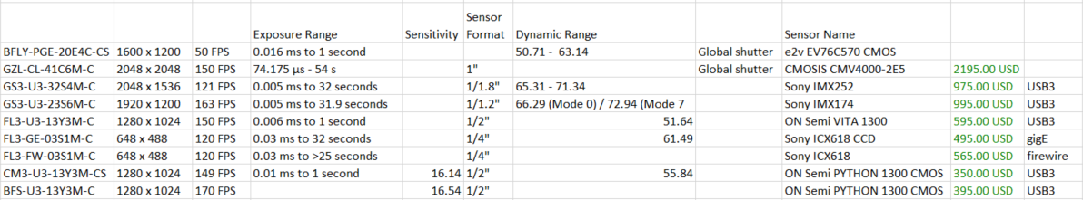

From the FLIR web site: possible candidate cameras with global shutter

From the above table, selected 3 cameras for prototype tests

High end: GS3-U3-23S6M-C $995.00

* Large sensor 1/1.2”, Sony IMX174 (new Pregius global shutter technology)
* high dynamic range: 66.29 (Mode 0) / 72.94 (Mode 7)
* 1920 x 1200
* 163 FPS

Mid Range: BFS-U3_32S4M-C, $725.00

* Sensor size 1/1.8”, Sony ICX618 CCD
* great dynamic range: 70.39
* high resolution: 2048 x 1536
* low end frame rate at 118 FPS

Low end: BFS-U3-13Y3M-C, $395

* sensor size, 1/2” ON Semi PYTHON 1300 CMOS
* low end dynamic range: 55.84
* mid range resolution: 1280 x 1024
* fastest: 170 FPS

The above cameras cover a fairly wide range of the available specs and price and would allow us to evaluate sensor size, dynamic range, resolution and frame rate parameters.

## Lens Selection

From the algorithm evaluation experiments with 8 mm lens, resolution was found to be

4506.7, 4526.7, 4688, the third measurement method was not as good as the first 2, so estimate the resolution at 4516.7 pix/m. The camera was BLFY-PGE-20E4C-CS (1/1.8”) with 8MM 1/1.8 ir mp lens. The field of view, 1600 x 1200. The measured field of view is 1600 / 4516.7 = 0.3542 m. Half width is 17.71 cm at 37 cm height giving theta = tan^-1(17.71/37) = 25.6 deg or 51.2 deg full width. A Tamron 8 mm, 1/1.8 lens data sheet says 50.8 deg when matched with 1/1.8 sensor (fairly good agreement).

All of the above cameras will do at least 120 fps (if the data sheets are to be believed) so assuming this frame rate, and max speed of 130 km/hr,

130 km/hr * 1000/3600 = 36.11 m/s

D = 36.11 m/s / 120 frames/sec = 0.301 m/frame (vehicle motion). If we assume that 1/8 of this distance is enough to do image registration, then limit on frame size is 8/7 * 0.301 = 0.344 m.

This distance as a function of frame rate is

D = 36.11 m/s / FPS * 8/7

Required lens angle as a function of mounting height is then

Theta = tan^-1 (0.344/2 / H)

Where H is the camera mounting height

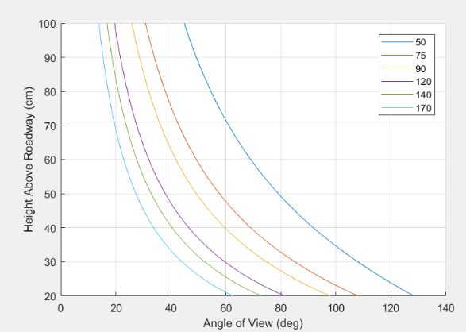

The above plot should be useful in determining the required mounting height, given a lens view angle. The colored lines in the plot correspond to different frame rates.

Lenses by camera

High end, Large sensor 1/1.2”, 163 FPS

Using available Tamron lenses

1/1.2, 8 mm, [16:9], 75.3 deg (less than 20 cm height)

1/1.2, 12 mm, [16:9], 53.2 deg (about 25 cm height)

1/1.2, 16 mm, [16:9], 40.5 deg (about 33 cm height)

At lower frame rate,

1/1.2, 8 mm, [16:9], 75.3 deg

possible to use frame rates as low as 50 fps with H = 60 cm, keeping H ~ 37 cm, frame rates of 75 – 90 are possible.

To select 2 lenses for this camera, the 8 mm lens enables lowest frame rate. 8mm and 16 mm cover a broad range of operating conditions.

Mid Range Camera, 1/1.8" sensor, 120 fps

1/1.8, 6mm matched with (1/1.8” sensor), 66.1 deg (26 cm height)

1/1.8, 8mm matched with (1/1.8” sensor), 50.8 deg (36 cm height)

1/1.8, 12mm matched with (1/1.8” sensor), 34.2 deg (56 cm height)

Low end Camera, 1/2” sensor, 170 fps

1/1.8, 6mm mismatched with (1/2” sensor), 58.9 deg (21 cm height)

1/1.8, 8mm mismatched with (1/2” sensor), 45.0 deg (29 cm height)

1/1.8, 12mm mismatched with (1/2” sensor), 30.2 deg (45 cm height)

Recommended lens selection

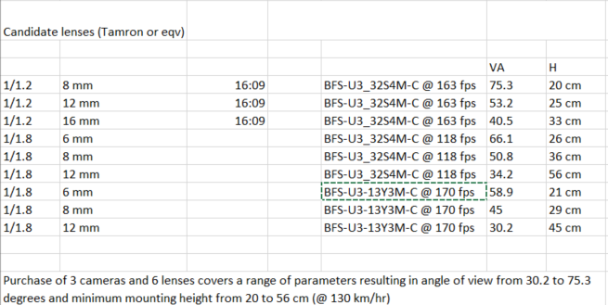

VA is the viewing angle and H is the minimum mounting height to obtain a large enough frame for position shift computation at 130 km/hr

### Range Finder

Ultrasonic range finders seem the best bet. Optical have much greater range but do not have the required resolution. Typical range finders that might be good candidates:

Parallax PING))) Ultrasonic Sensor #28015

HC-SR04 Ultra01+ Ultrasonic Range Finder

The above are pulse type sensors that would require a microcontroller to output distance. Most other sensor types have data rate that is much lower than the camera frame rate needed.

Maxbotix makes sensors that have mm resolution with readout rates of 10 Hz. These might be good for on the fly calibration, but not point to point calibration. These units are available with RS232 interface and cost about 30 – 40 $.

MB1330 XL-MaxSonar-AE3

### Data Collection

For the prototype, the standard data collection system – PC used for the T4 rig, will be used. Data will be simply collected from the camera (and range finder if used) and stored to the computer’s internal 1 TB disk. To meet the needs of the higher frame rate/higher pixel depth/higher resolution modes, we will need a faster data storage solution, e.g., Samsung 960 EVO Series, NVMe M.2 Internal SSD (512 GB or 1 TB) (512 GB - $234, 1TB - $435). We will also need about 6 TB of external storage.